 | SCOM Plug-in for eSight
 | User Guide
 | Issue | 01
 | Date | 2018-02-09
Preface
Purpose
This document describes how to install and uninstall the SCOM plug-in, add and delete eSight, view server information and status, view event lists, view alarm lists, and view server topologies.
Intended Audience
This document is intended for:
- Technical support engineers
- System maintenance engineers
Symbol Conventions
The symbols that may be found in this document are defined as follows.
Symbol | Description
 | Indicates an imminently hazardous situation which, if not avoided, will result in death or serious injury.
 | Indicates a potentially hazardous situation which, if not avoided, could result in death or serious injury.
 | Indicates a potentially hazardous situation which, if not avoided, may result in minor or moderate injury.
 | Indicates a potentially hazardous situation which, if not avoided, could result in equipment damage, data loss, performance deterioration, or unanticipated results.  NOTICE is used to address practices not related to personal injury.
Calls attention to important information, best practices and tips.
NOTE is used to address information not related to personal injury, equipment damage, and environment deterioration.

Change History
Issue | Date | Description
01 | 2018-02-09 | This issue is the first official release.

Contents
Preface ii
1 Overview 1
2 Installing and Uninstalling the SCOM Plug-in 3
2.1 Installing the SCOM Plug-in 3
2.2 Uninstalling the SCOM Plug-in 10
3 Configuring eSight 17
3.1 Adding eSight 17
3.2 Editing eSight 24
3.3 Deleting eSight 27
4 Viewing the Basic Information and Status of Servers 30
4.1 Viewing the Basic Information and Status of a Blade Server 30
4.2 Viewing the Basic Information and Status of a Rack Server 36
4.3 Viewing the Basic Information and Status of a High-Density Server 39
4.4 Viewing the Basic Information and Status of a KunLun Server 42
5 Viewing an Event List 46
6 Viewing an Alarm List 48
7 Viewing Server Topologies 50
7.1 Viewing a Huawei Server Topology 50
7.2 Viewing a Blade Server Topology 52
7.3 Viewing a Rack Server Topology 54
7.4 Viewing a High-Density Server Topology 56
7.5 Viewing a KunLun Server Topology 58
A Glossary 61

Overview
The SCOM plug-in is a plug-in integrated in SCOM. By interconnecting with eSight, the SCOM plug-in can monitor the health status and alarms of blade servers, rack servers, high-density servers, and KunLun servers deployed on eSight. You can implement the following functions by using the SCOM plug-in system:
- Configure and manage multiple eSight instances.
- View the information of servers and components managed by eSight.
- View the health status of servers and components managed by eSight.
- View the alarm change information synchronized with eSight.
- View the device change information generated by eSight.
- View the topologies of servers managed by eSight.
The compatibility between the SCOM plug-in and eSight, SCOM, and servers is as follows:
- eSight V300R008C00SPC200 or later is supported.
- SCOM 2012 R2 and SCOM 2016 are supported.
- Table 1-1 lists the supported servers.
                - Supported servers
Type | Server
Rack server | RH2288H V2,RH1288 V3,RH2288 V3,RH2288H V3,RH5885 V3,RH8100 V3,RH1288H V5,RH2288H V5,RH2488 V5
Blade server | E9000
High-density server | XH321 V3,XH620 V3,XH622 V3,XH628 V3
KunLun server | 9008L,9016,9032L

Installing and Uninstalling the SCOM Plug-in

Installing the SCOM Plug-in
Prerequisites
- SCOM 2012 R2 or SCOM 2016 has been installed on the SCOM server.
- .Net Framework4.0 or later has been installed on the SCOM server.
Procedure
            - Download the SCOM plug-in installation package of the latest version from the GitHub website, for example, Huawei_SCOM_Plugin_For_eSight-Setup_1.0.zip.
            - Upload the SCOM plug-in installation package to the SCOM server.
            - Log in to the SCOM server.
            - Decompress the SCOM plug-in installation package.
Obtain the installation application, for example, Huawei_SCOM_Plugin_For_eSight-Setup_1.0.exe.
            - Double-click Huawei_SCOM_Plugin_For_eSight-Setup_1.0.exe.
The Welcome to Huawei SCOM Plugin For eSight 1.0 Setup window is displayed, as shown in Figure 1-1.
              - Welcome to Huawei SCOM Plugin For eSight 1.0 Setup
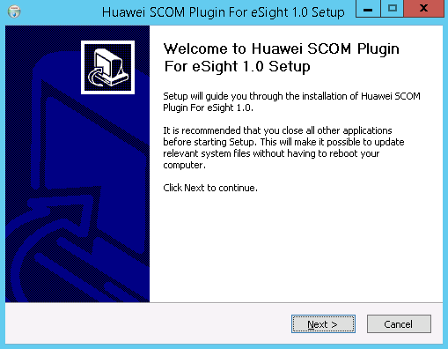

            - Click Next.
The Choose Install Location window is displayed, as shown in Figure 1-1.
              - Choose Install Location
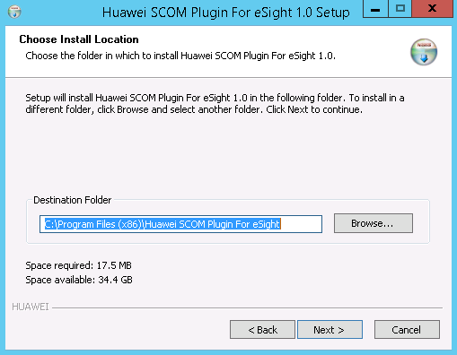

            - Retain the default installation path or click Browse to change the installation path, and click Next.
The IP/Port Configuration window is displayed, as shown in Figure 1-1.
              - IP/Port Configuration
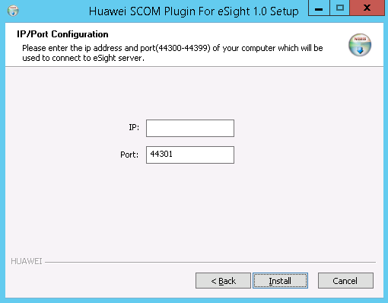

            - Enter the IP address and port number of the SCOM server that is used to connect to eSight. (The port number ranges from 44300 to 44399. You are advised to retain the default value 44301.) Click Install.
The SCOM plug-in installation starts, as shown in Figure 1-1.
              - Installing the SCOM plug-in
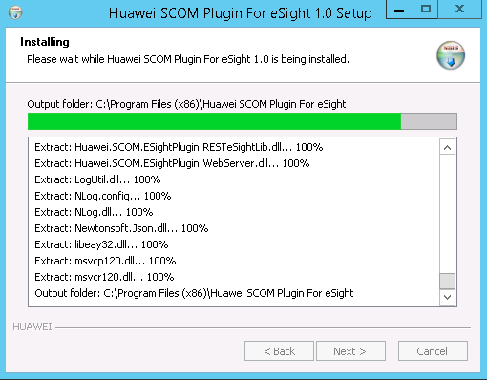

After the installation is complete, the Completing Huawei SCOM Plugin For eSight 1.0 Setup window is displayed, as shown in Figure 1-2.
              - Completing Huawei SCOM Plugin For eSight 1.0 Setup
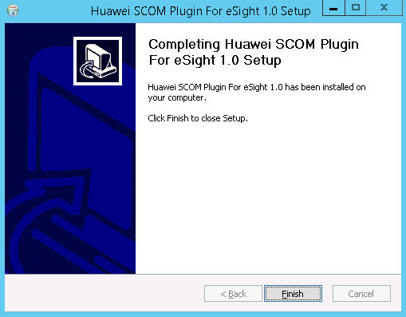

            - Click Finish.
The SCOM plug-in installation is complete.
            - Choose Start > > Operations Console.
The SCOM main window is displayed, as shown in Figure 1-1.
              - SCOM main window
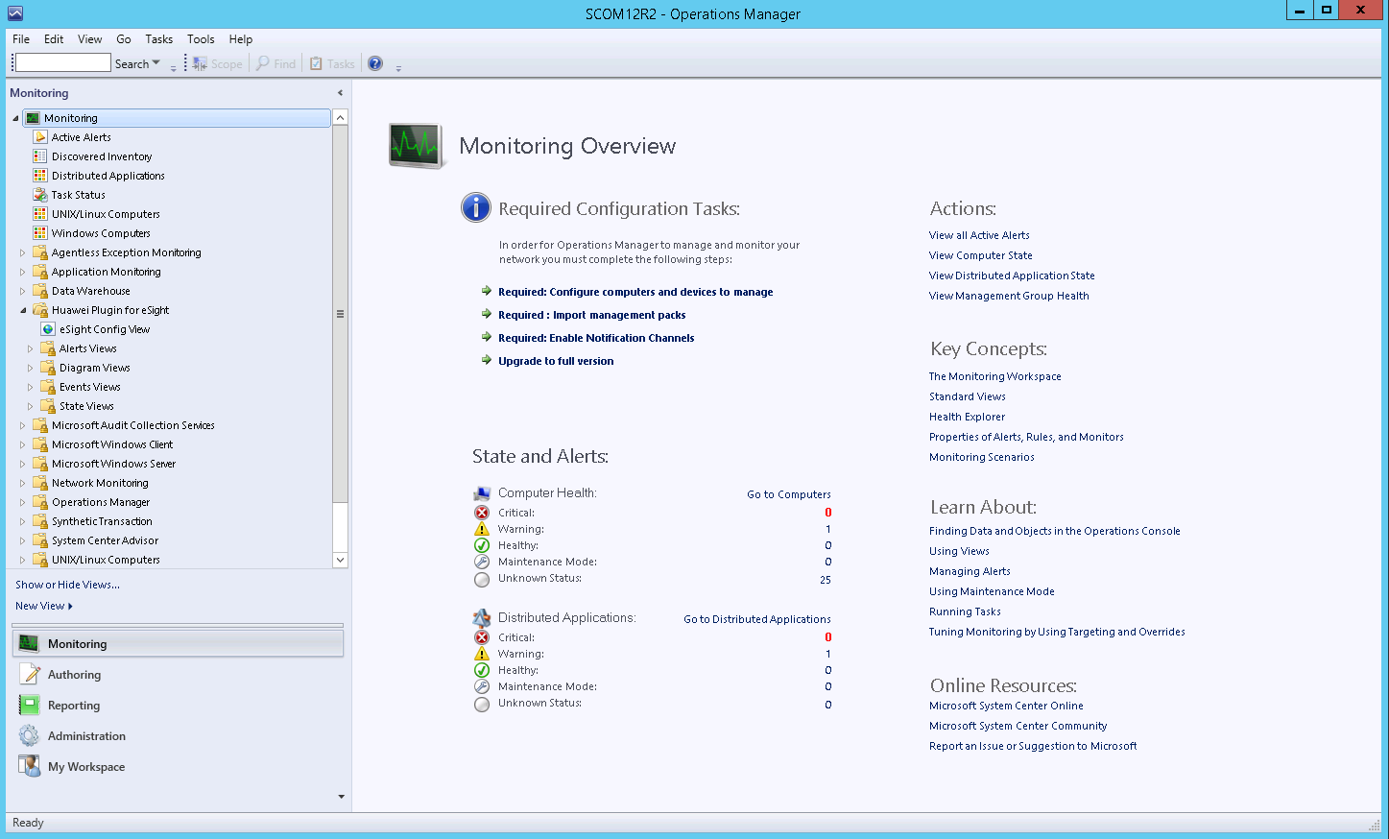

            - Choose Administration > Management Packs.
The Management Packs window is displayed, as shown in Figure 1-1.
              - Management Packs
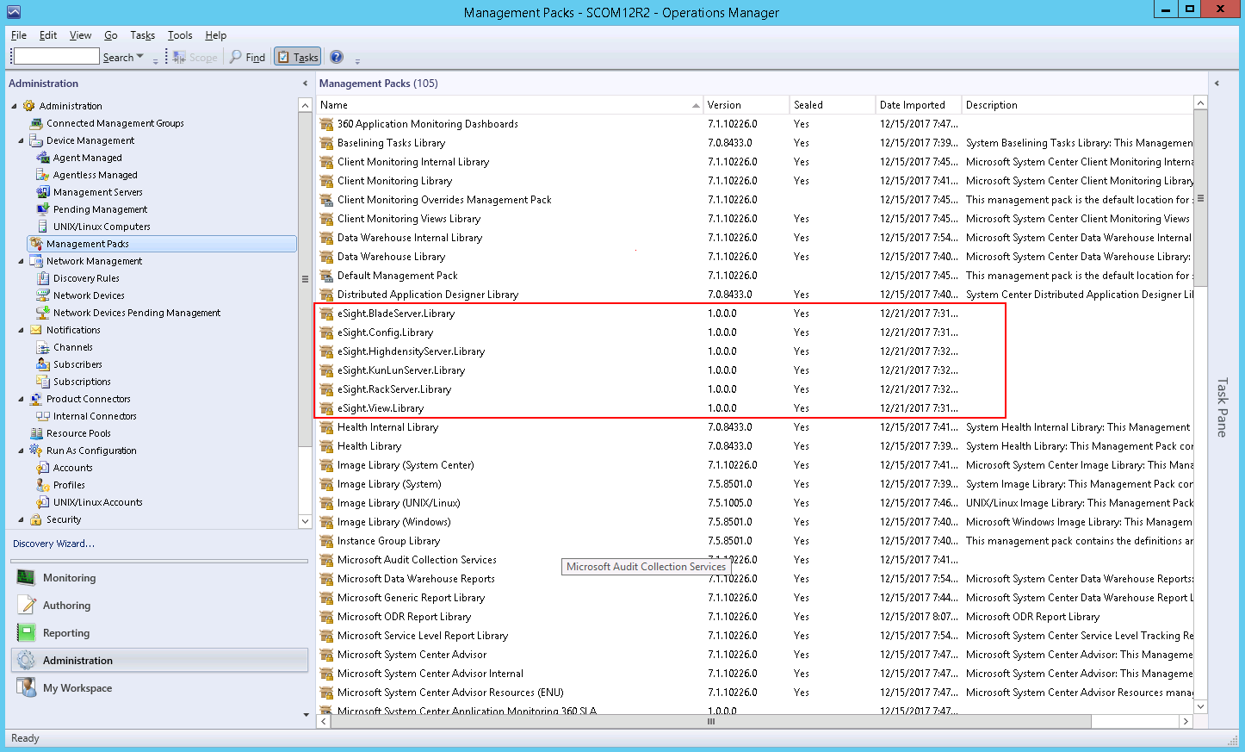

After the SCOM plug-in is successfully installed, the Manage Package (MP) packages in the red box are displayed in the Management Packs window.
After the MP packages are successfully installed, the nodes in the red box are displayed in the SCOM main window, as shown in Figure 1-2.
              - SCOM main window
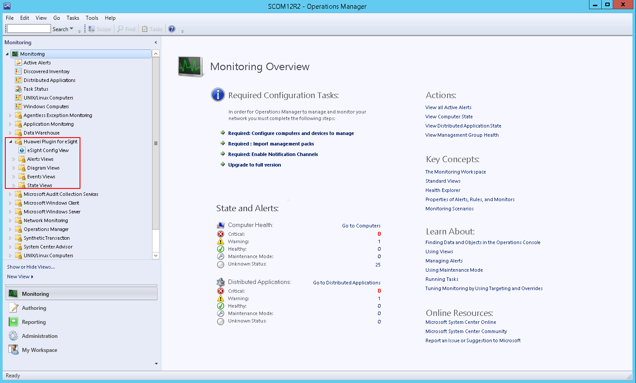

----End

Uninstalling the SCOM Plug-in
You need to close the SCOM window before uninstalling the SCOM plug-in.
Uninstalling the SCOM Plug-in from the Control Panel
            - Choose Start > Control Panel > Programs and Features > Uninstall a program.
The Uninstall or change a program window is displayed, as shown in Figure 1-1.
              - Uninstall or change a program
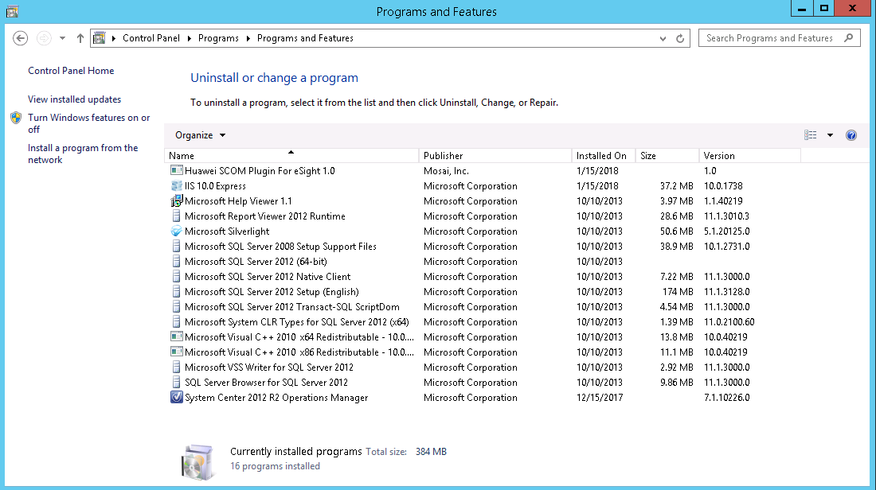

            - Double-click the SCOM plug-in (for example, Huawei SCOM Plugin For eSight 1.0).
A confirmation dialog box is displayed, as shown in Figure 1-1.
              - Dialog box
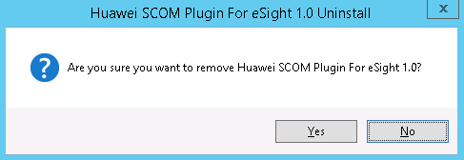

            - Click Yes.
The dialog box asking you whether to save the eSight configuration information is displayed, as shown in Figure 1-1.
              - Dialog box
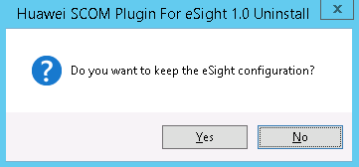

- If the eSight configuration information needs to be saved, click Yes.
- If the eSight configuration information does not need to be saved, click No.
            - Click Yes or No.
The dialog box asking you whether to uninstall IIS Express is displayed, as shown in Figure 1-1.
              - Dialog box
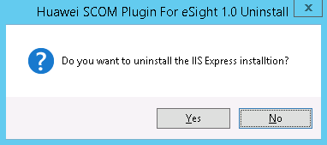

IIS Express is responsible for the communication between the plug-in and SCOM. After IIS Express is uninstalled, it will be reinstalled when the SCOM plug-in is installed.
- If IIS Express needs to be uninstalled, click Yes.
- If IIS Express does not need to be uninstalled, click No.
            - Click Yes or No.
The SCOM plug-in uninstallation starts, as shown in Figure 1-1.
              - Uninstalling the SCOM plug-in
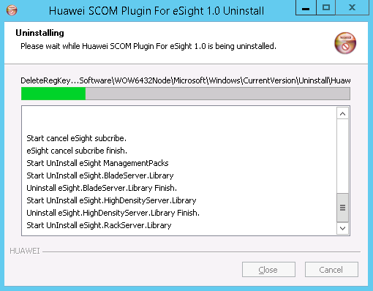

After the uninstallation is complete, the dialog box shown in Figure 1-2 is displayed.
              - Uninstallation completed
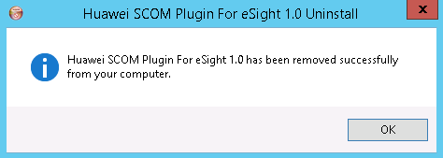

            - Click OK.
The SCOM plug-in is uninstalled.
----End
Uninstalling the SCOM Plug-in from the Installation Directory
            - Go to the installation directory of the SCOM plug-in (C:\Program Files (x86) \Huawei SCOM Plugin For eSight), as shown in Figure 1-1.
              - Installation directory of the SCOM plug-in
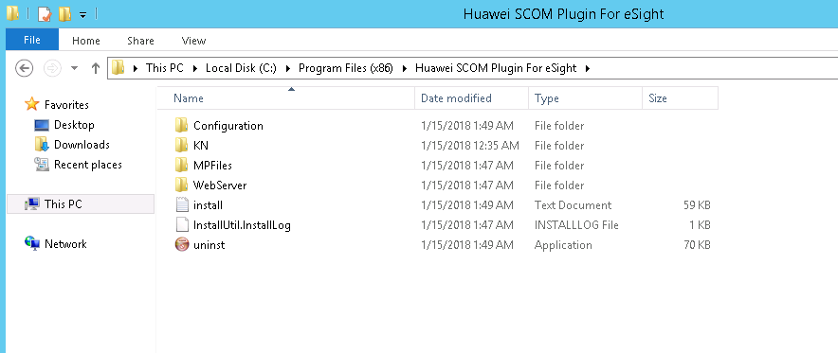

            - Double-click uninst.
A confirmation dialog box is displayed, as shown in Figure 1-1.
              - Dialog box

            - Click Yes.
The dialog box asking you whether to save the eSight configuration information is displayed, as shown in Figure 1-1.
              - Dialog box

- If the eSight configuration information needs to be saved, click Yes.
- If the eSight configuration information does not need to be saved, click No.
            - Click Yes or No.
The dialog box asking you whether to uninstall IIS Express is displayed, as shown in Figure 1-1.
              - Dialog box

IIS Express is responsible for the communication between the plug-in and SCOM. After IIS Express is uninstalled, it will be reinstalled when the SCOM plug-in is installed.
- If IIS Express needs to be uninstalled, click Yes.
- If IIS Express does not need to be uninstalled, click No.
            - Click Yes or No.
The SCOM plug-in uninstallation starts, as shown in Figure 1-1.
              - Uninstalling the SCOM plug-in

After the uninstallation is complete, the dialog box shown in Figure 1-2 is displayed.
              - Uninstallation completed

            - Click OK.
The SCOM plug-in is uninstalled.
----End

Configuring eSight

Adding eSight
- KunLun servers have many components. When you add a KunLun server on eSight and set the discovery time to the maximum value 60 seconds, you can click the refresh button to increase the speed of obtaining component information, as shown in Figure 1-1. For details, see the eSight V300R008C00 Product Documentation.
- A maximum of 50 eSight instances can be added.
              - Accelerating the obtaining of KunLun server component information
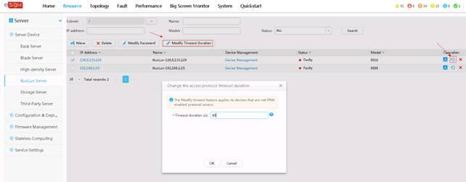

            - Set a whitelist.
By default, a whitelist of eSight northbound ports is configured. To add an eSight system properly, you must add the IP address of the server where SCOM is located to the whitelist of eSight northbound ports.
- Log in to the eSight WebUI.
- Choose System > Whitelist Settings > IPV4.
The page for adding a whitelist is displayed, as shown in Figure 1-1.
              - Adding a whitelist
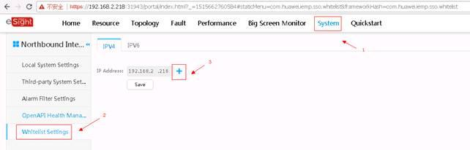

- Click , enter the IP address of the SCOM server, and click Save.
The IP address of the SCOM server is set as a whitelist.
            - Obtain the third-party system ID of eSight.
- Log in to the eSight WebUI.
- Choose System > Northbound Integration > Third-party System > Create.
The Third-party System page is displayed, as shown in Figure 1-1.
              - Third-party System
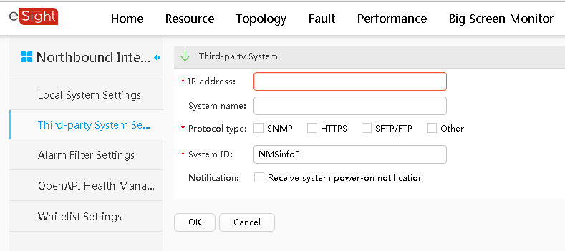

The default value of System ID of eSight is NMSinfo+Number of third-party systems.
- Set the following parameters:
- IP address: Set this parameter to the IP address of the SCOM server.
- Protocol type: Select HTTPS.
- System ID: Retain the default value or enter a new value. The value can be an IP address or a string of 1 to 64 characters, including digits (0-9), lowercase letters (a-z), uppercase letters (A-Z), and special characters @_- (), .^$~`!.
- Click OK.
SCOM is successfully added to eSight, as shown in Figure 1-2.
              - SCOM added successfully
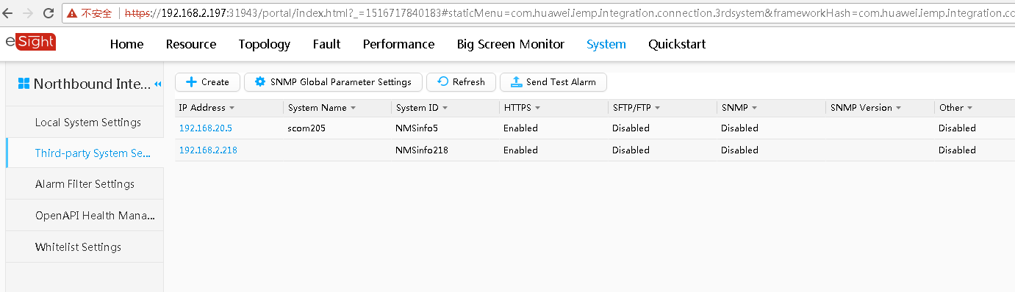

In the third-party system list area on the right, the value of System ID in the row where the SCOM server IP address is located is the eSight third-party system ID.
            - Choose Start > > Operations Console.
The SCOM main window is displayed, as shown in Figure 1-1.
              - SCOM main window

            - Choose Monitoring > Huawei Plugin for eSight > eSight Config View.
The eSight Config View window is displayed, as shown in Figure 1-1.
              - eSight Config View
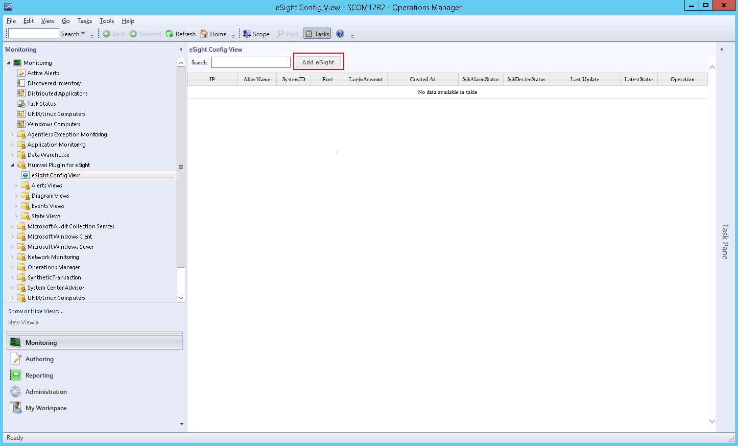

            - Click Add eSight.
The Add eSight page is displayed, as shown in Figure 1-1.
              - Add eSight
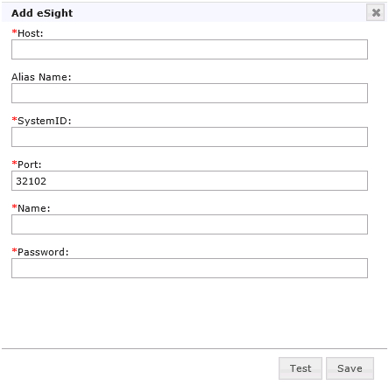

Table 1-1 describes the parameters.
                - Parameter description
Parameter | Parameter Description | Value | Mandatory
Host | eSight IP address | The value is in the XXX.XXX.XXX.XXX format. X is an integer. | Yes
Alias Name | Customized eSight name | The value is a string of 1 to 100 characters, including letters, digits, underscores (_), hyphens (-), and periods (.). | No
SystemID | Third-party system ID | Value obtained in step 2. | Yes
Port | eSight northbound port number | The default value is 32102. | Yes
Name | eSight northbound port user name | The default value is openApiUser. | Yes
Password | eSight northbound port password | The default value is Changeme_123. | Yes

            - Enter eSight information, and click Test to test whether the SCOM server can connect to eSight.
If the test is successful, "Link test successfully" is displayed, as shown in Figure 1-1. If the test fails, the failure cause is displayed. Modify eSight information as prompted.
              - Successful test
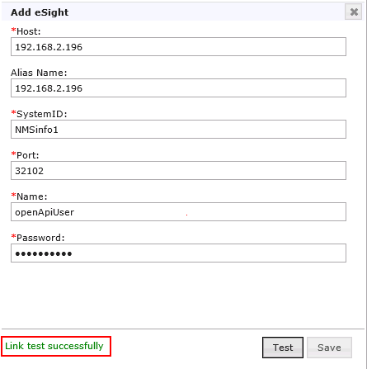

            - Click Save.
The eSight information is saved in the list and a dialog box is displayed, indicating that the eSight is added successfully, as shown in Figure 1-1.
              - eSight added successfully
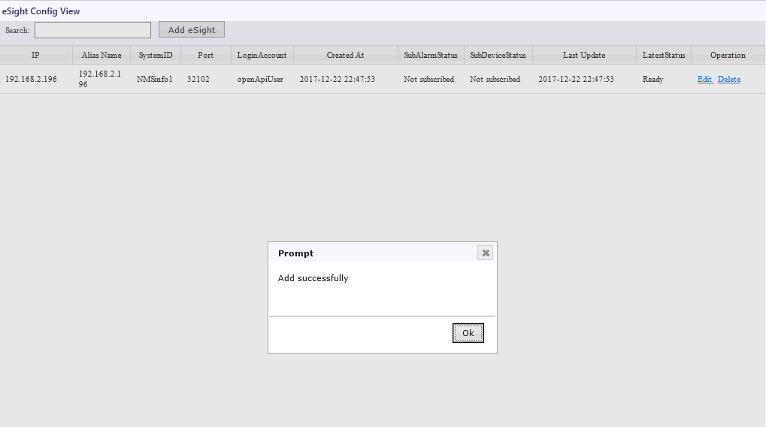

            - Click OK.
The eSight is added successfully, as shown in Figure 1-1.
              - eSight added successfully
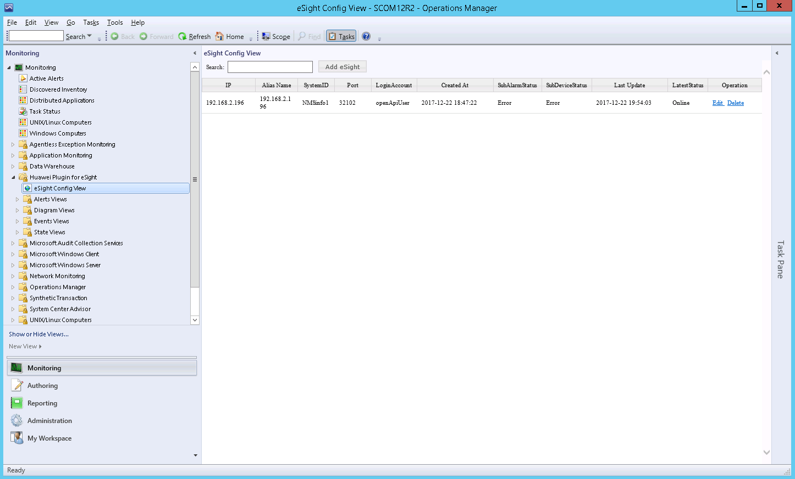

----End

Editing eSight
            - Choose Start > > Operations Console.
The SCOM main window is displayed, as shown in Figure 1-1.
              - SCOM main window

            - Choose Monitoring > Huawei Plugin for eSight > eSight Config View.
The eSight Config View window is displayed, as shown in Figure 1-1.
              - eSight Config View

If the eSight information in the right pane is empty, no eSight has been connected.
            - Click Edit in the row where eSight is located in the right pane. Edit is in the Operation column.
The Edit eSight window is displayed, as shown in Figure 1-1.
              - Edit eSight
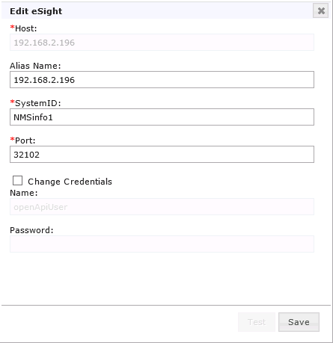

            - Edit eSight information according to Table 1-1, and click Save.


- The eSight IP address cannot be modified.
- Change Credentials must be selected if the eSight northbound port user name and password are to be changed.
A dialog box indicating successful editing is displayed, as shown in Figure 1-1.
              - Edited successfully
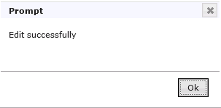

            - Click OK.
The eSight is successfully edited, as shown in Figure 1-1. On this page, you can check whether the modified information is consistent with the target.
              - Modified eSight information
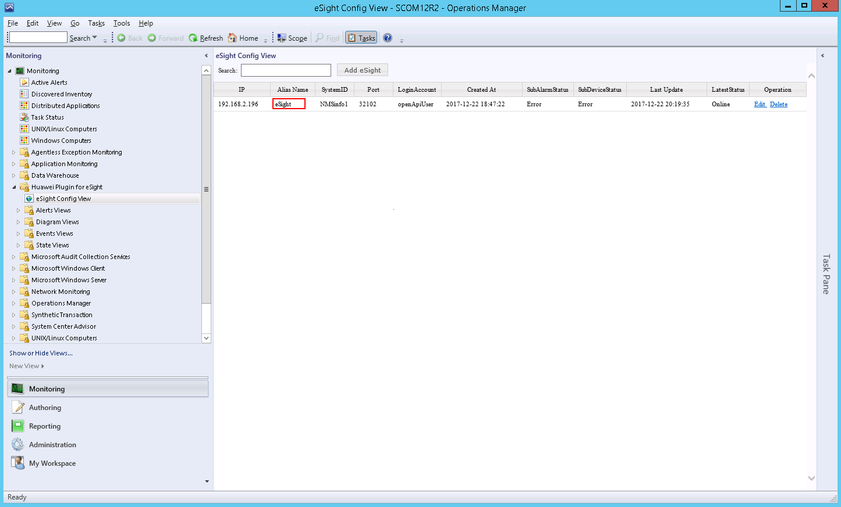

----End

Deleting eSight
            - Choose Start > > Operations Console.
The SCOM main window is displayed, as shown in Figure 1-1.
              - SCOM main window

            - Choose Monitoring > Huawei Plugin for eSight > eSight Config View.
The eSight Config View window is displayed, as shown in Figure 1-1.
              - eSight Config View

If the eSight information in the right pane is empty, no eSight has been connected.
            - Click Delete in the row where eSight is located in the right pane. Delete is in the Operation column.
A confirmation dialog box is displayed, as shown in Figure 1-1.
              - Dialog box
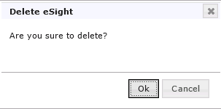

            - Click OK.
The eSight is successfully deleted, as shown in Figure 1-1. On this page, you can check whether the target eSight has been deleted.
              - eSight deleted successfully
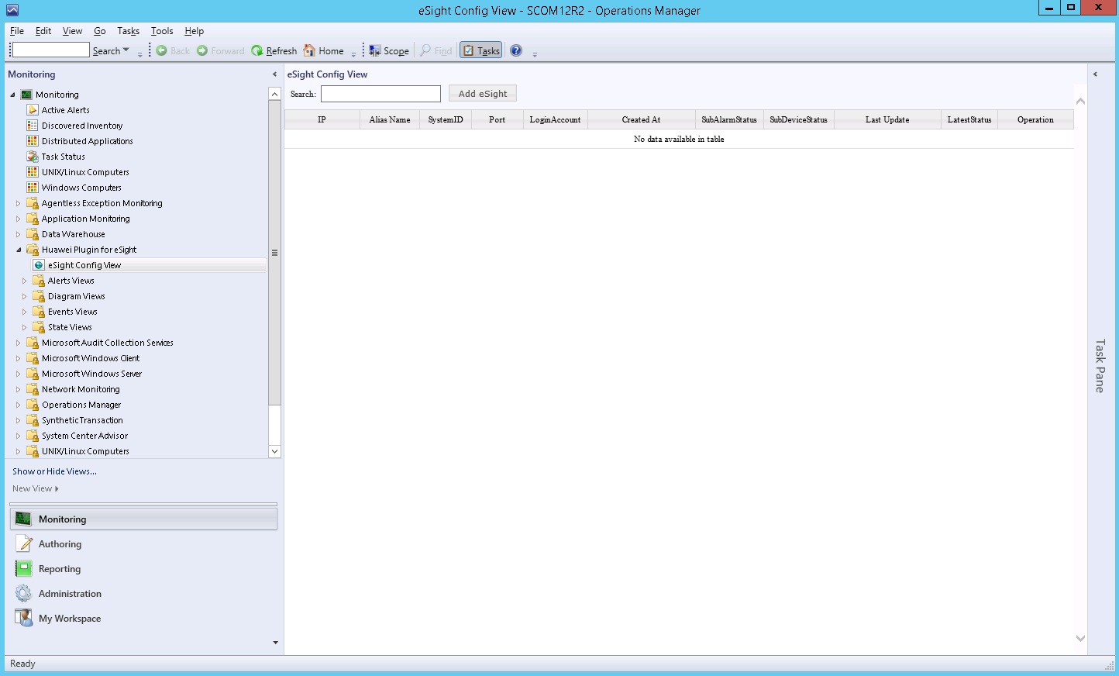

----End

Viewing the Basic Information and Status of Servers

Viewing the Basic Information and Status of a Blade Server
            - Choose Start > > Operations Console.
The SCOM main window is displayed, as shown in Figure 1-1.
              - SCOM main window

            - Choose Monitoring > Huawei Plugin for eSight > State Views > BladeServer State.
The BladeServer State window is displayed, as shown in Figure 1-1. On this page, the managed servers are displayed in different rows, and the status of the monitored components on each server is displayed in different columns.
              - BladeServer State
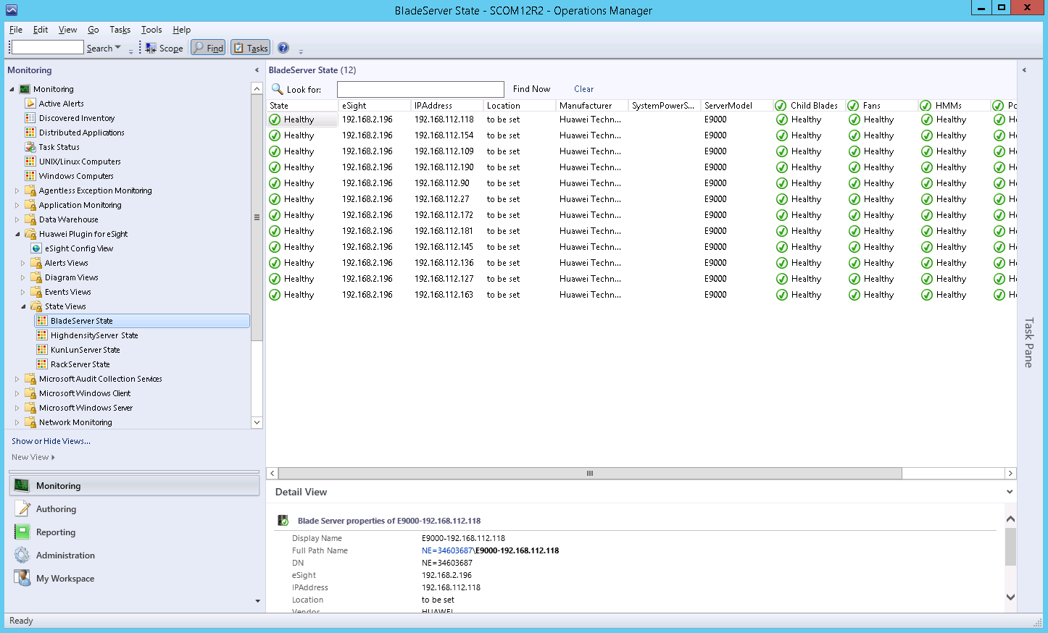

In the BladeServer State area, you can click any position in the row of a server to view details about the server in the Detail View area.
The component health status is described as follows:
- : Healthy, absent, or unknown status
- : Minor alarms
- : Major or critical alarms
The overall health status depends on the server system status and is irrelevant to the component status.
            - Set the components and monitoring parameters to be displayed.
- Right-click the name or status of a component and choose Personalize View... from the shortcut menu.
The Personalize View window is displayed, as shown in Figure 1-1.
              - Personalize View
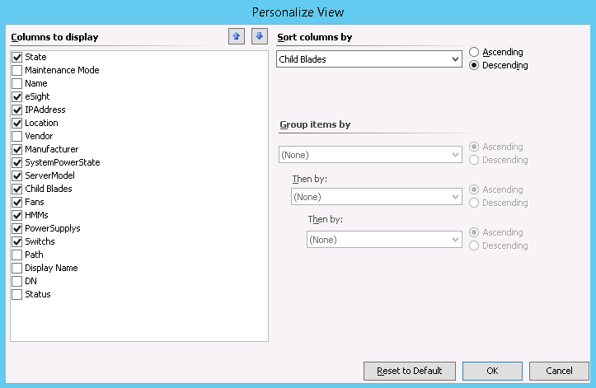

- Select the components to be monitored, and click OK.
The components to be monitored are modified successfully.
- Right-click the component status (for example, Healthy under Fans) and choose Open > State View from the shortcut menu or double-click the component status.
The State window of the component is displayed, as shown in Figure 1-2.
              - State
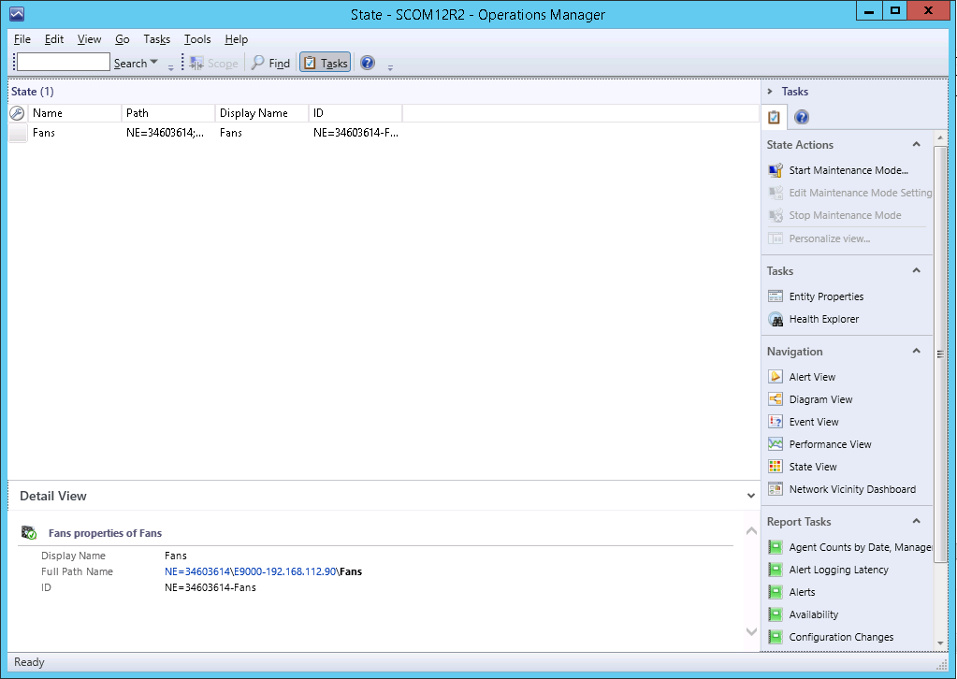

- Right-click a row in the State area and choose Personalize View... from the shortcut menu.
The Personalize View window is displayed, as shown in Figure 1-3.
              - Personalize View
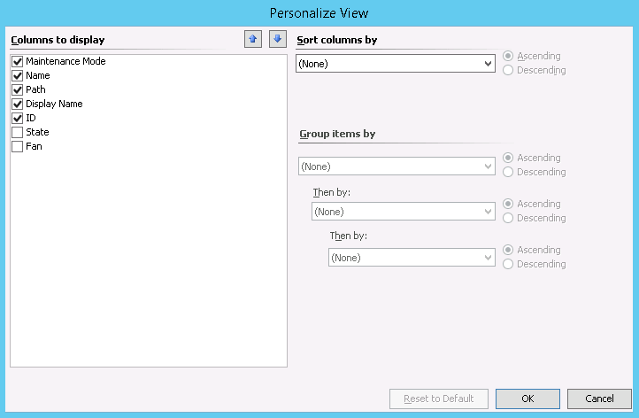

- In the Columns to display list box, select the parameters to be displayed, and click OK.
The State window is displayed, as shown in Figure 1-4.
              - State
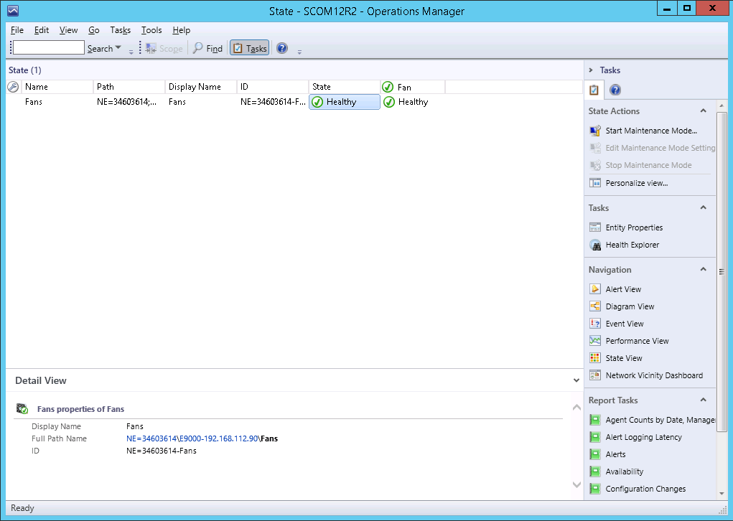

Table 1-1 lists the blade server components and parameters that can be monitored by the SCOM plug-in.
                - Blade server components and parameters that can be monitored
Service Name | Component | Parameter
Fan | Fan | - UUID: UUID  - State: health status  - PresentState: presence status  - ControlModel: control type  - RotatePercent: rotation percentage  - fanSpeed: fan speed  - fanInfo: fan information  - fanVersion: fan version
PowerSupply | PSU | - UUID: UUID  - State: health status  - PresentState: presence status  - PowerMode: PSU working mode  - RatingPower: rated power  - RuntimePower: real-time power
Switch | Switch module | - UUID: UUID  - State: health status  - BladeVersion: blade version  - SwitchType: switch module model  - ProductName: product name  - BoardManufacturer: mainboard manufacturer  - BoardPartNumber: mainboard part number  - BoardSerialNumber: mainboard serial number  - BoardManufactureDate: mainboard manufacturing date  - ProductDescription: product description  - ProductManufacturer: product manufacturer  - ProductPartNumber: product part number  - ProductSerialNumber: product serial number
Child Blade | Blade | - UUID: UUID  - State: health status  - PresentState: presence status  - BmcIP: BMC IP address  - BmcMask: BMC mark  - ProductName: product name  - BladeVersion: blade version  - BoardSerialNumber: mainboard serial number  - BoardManufactureDate: mainboard manufacturing date  - ProductDescription: product description  - ProductSerialNumber: product serial number  - SystemCPUUsage: system CPU usage
HMM | E9000 management module | - UUID: UUID  - State: health status  - PresentState: presence status  - ProductName: product name  - AmbientTemp: ambient temperature  - InletTemp: air inlet temperature  - LSWTemp: switch module temperature  - OutletTemp: air outlet temperature  - SoftwareVersion: software version  - BoardSerialNumber: mainboard serial number  - ProductSerialNumber: product serial number  - smmOtherVersion: other firmware versions  - smmHostname: host name  - smmRedundancy: presence status of the active and standby management modules
CPU | Blade server CPU | - State: health status  - UUID: UUID  - PresentState: CPU presence status  - CPUInfo: CPU information
Disk | Blade server hard disk | - State: health status  - UUID: UUID  - PresentState: hard disk presence status  - DiskLocation: hard disk location  - DiskSerialNumber: hard disk serial number  - DiskINterfaceType: hard disk interface type  - DiskCapcity: hard disk capacity  - DiskManufacturer: hard disk manufacturer
Memory | Blade server memory | - State: health status  - UUID: UUID  - PresentState: memory presence status  - Manufacturer: manufacturer  - Frequency: memory frequency  - Capacity: memory capacity
Mezz | Blade server mezzanine card | - State: health status  - UUID: UUID  - PresentState: mezzanine card presence status  - MezzInfo: mezzanine card information  - MezzLocation: mezzanine card location  - MezzMac: mezzanine card MAC address
RaidController | Blade server RAID controller card | - State: health status  - UUID: UUID  - Type: RAID controller card type  - DeviceInterface: RAID controller card hardware interface  - FwVersion: RAID controller card firmware version  - BBUPresence: BBU presence status  - BBUType: BBU type

----End

Viewing the Basic Information and Status of a Rack Server
            - Choose Start > > Operations Console.
The SCOM main window is displayed, as shown in Figure 1-1.
              - SCOM main window

            - Choose Monitoring > Huawei Plugin for eSight > State Views > RackServer State.
The RackServer State window is displayed, as shown in Figure 1-1. On this page, the managed servers are displayed in different rows, and the status of the monitored components on each server is displayed in different columns.
              - RackServer State
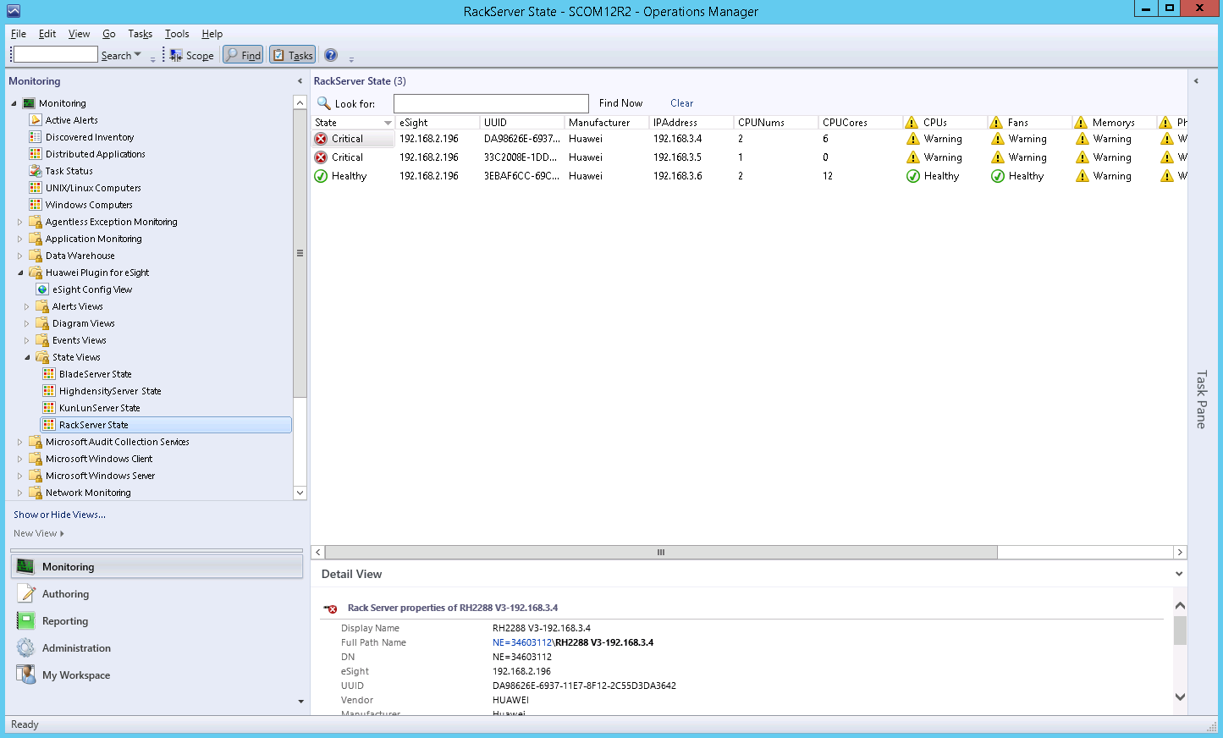

In the RackServer State area, you can click any position in the row of a server to view details about the server in the Detail View area.
The component health status is described as follows:
- : Healthy, absent, or unknown status
- : Minor alarms
- : Major or critical alarms
The overall health status depends on the server system status and is irrelevant to the component status.
            - Set the components and monitoring parameters to be displayed. For details, see Step 3 in 4.1 Viewing the Basic Information and Status of a Blade Server.
Table 1-1 lists the rack server components and parameters that can be monitored by the SCOM plug-in.
                - Rack server components and parameters that can be monitored
Service Name | Component | Parameter
Fan | Fan | - UUID: UUID  - State: health status  - PresentState: presence status  - RotatePercent: rotation percentage  - Speed(RPM): fan speed
PowerSupply | PSU | - UUID: UUID  - State: health status  - PresentState: presence status  - Manufacturer: manufacturer  - InputMode: input mode  - Model: type  - PowerRating: rated power  - InputPower: input power
CPU | CPU | - State: health status  - UUID: UUID  - PresentState: CPU presence status  - Manufacturer: manufacturer  - Type: type  - Frequency: frequency (MHz)  - CoreCount: number of cores
PhysicalDisk | Hard disk | - State: health status  - UUID: UUID  - PresentState: hard disk presence status  - Locator: hard disk location  - Diskcapacity(GB): hard disk capacity  - IndterfaceType: hard disk interface type
Memory | Memory | - State: health status  - UUID: UUID  - PresentState: memory presence status  - Manufacturer: manufacturer  - Frequency: memory frequency  - Size: memory capacity
RaidController | RAID controller card | - State: health status  - UUID: UUID  - Type: RAID controller card type  - DeviceInterface: RAID controller card hardware interface  - FirmwareVersion: RAID controller card firmware version  - DirverVersion: RAID controller card driver version  - BBUType: BBU type

----End

Viewing the Basic Information and Status of a High-Density Server
            - Choose Start > > Operations Console.
The SCOM main window is displayed, as shown in Figure 1-1.
              - SCOM main window

            - Choose Monitoring > Huawei Plugin for eSight > State Views > HighdensityServer State.
The HighdensityServer State window is displayed, as shown in Figure 1-1. On this page, the managed servers are displayed in different rows, and the status of the monitored components on each server is displayed in different columns.
              - HighdensityServer State
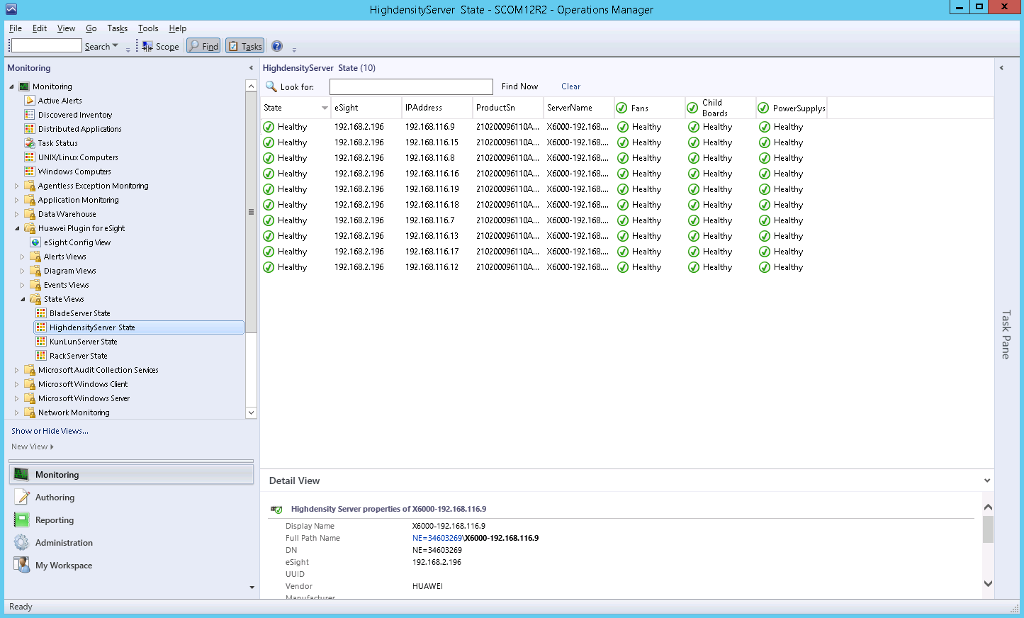

In the HighdensityServer State area, you can click any position in the row of a server to view details about the server in the Detail View area.
The component health status is described as follows:
- : Healthy, absent, or unknown status
- : Minor alarms
- : Major or critical alarms
The overall health status depends on the server system status and is irrelevant to the component status.
            - Set the components and monitoring parameters to be displayed. For details, see step Step 3 in 4.1 Viewing the Basic Information and Status of a Blade Server.
Table 1-1 lists the high-density server components and parameters that can be monitored by the SCOM plug-in.
                - High-density server components and parameters that can be monitored
Service Name | Component | Parameter
Fan | Fan | - UUID: UUID  - State: health status  - PresentState: presence status  - RotatePercent: rotation percentage  - Speed(RPM): fan speed
PowerSupply | PSU | - UUID: UUID  - State: health status  - PresentState: presence status  - Manufacturer: manufacturer  - InputMode: input mode  - Model: type  - PowerRating: rated power  - InputPower: input power
Child Board | Server node | - UUID: UUID  - State: health status  - IpAddress: IP address  - ProductSn: product SN  - Type: type
CPU | Server node CPU | - State: health status  - UUID: UUID  - PresentState: CPU presence status  - Manufacturer: manufacturer  - Type: type  - Frequency: frequency (MHz)  - CoreCount: number of cores
Disk | Server node hard disk | - State: health status  - UUID: UUID  - PresentState: hard disk presence status  - Locator: hard disk location  - Diskcapacity(GB): hard disk capacity  - IndterfaceType: hard disk interface type
Memory | Server node memory | - State: health status  - UUID: UUID  - PresentState: memory presence status  - Manufacturer: manufacturer  - Frequency: memory frequency  - Size: memory capacity
RaidController | Server node RAID controller card | - State: health status  - UUID: UUID  - Type: RAID controller card type  - DeviceInterface: RAID controller card hardware interface  - FirmwareVersion: RAID controller card firmware version  - DirverVersion: RAID controller card driver version  - BBUType: BBU type

----End

Viewing the Basic Information and Status of a KunLun Server
            - Choose Start > > Operations Console.
The SCOM main window is displayed, as shown in Figure 1-1.
              - SCOM main window

            - Choose Monitoring > Huawei Plugin for eSight > State Views > KunlunServer State.
The KunlunServer State window is displayed, as shown in Figure 1-1. On this page, the managed servers are displayed in different rows, and the status of the monitored components on each server is displayed in different columns.
              - KunlunServer State
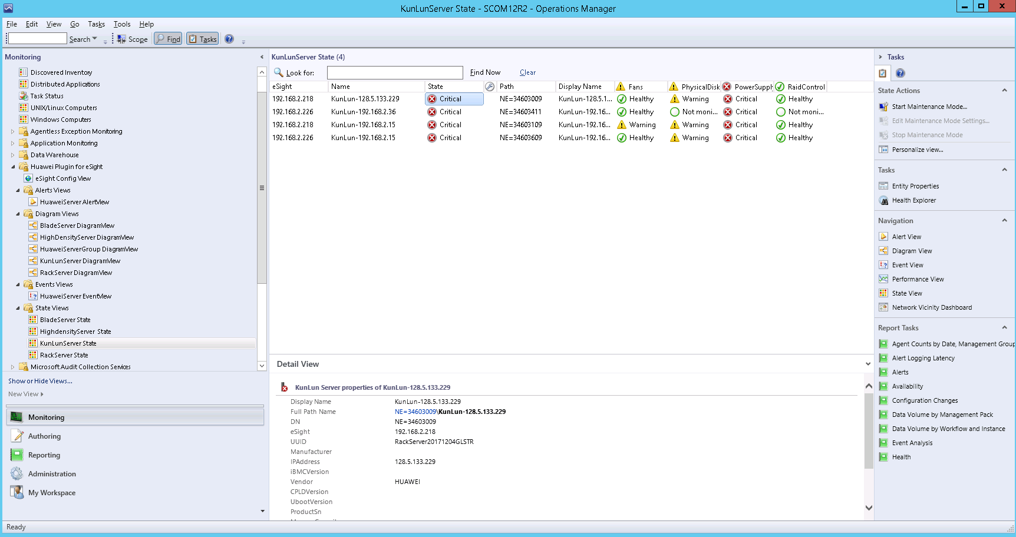

In the KunlunServer State area, you can click any position in the row of a server to view details about the server in the Detail View area.
The component health status is described as follows:
- : Healthy, absent, or unknown status
- : Minor alarms
- : Major or critical alarms
The overall health status depends on the server system status and is irrelevant to the component status.
            - Set the components and monitoring parameters to be displayed. For details, see step Step 3 in 4.1 Viewing the Basic Information and Status of a Blade Server.
Table 1-1 lists the KunLun server components and parameters that can be monitored by the SCOM plug-in.
                - KunLun server components and parameters that can be monitored
Service Name | Component | Parameter
Fan | Fan | - UUID: UUID  - State: health status  - PresentState: presence status  - RotatePercent: rotation percentage  - Speed(RPM): fan speed
PowerSupply | PSU | - UUID: UUID  - State: health status  - PresentState: presence status  - Manufacturer: manufacturer  - InputMode: input mode  - Model: type  - PowerRating: rated power  - InputPower: input power
PhysicalDisk | Hard disk | - State: health status  - UUID: UUID  - PresentState: hard disk presence status  - Locator: hard disk location  - Diskcapacity(GB): hard disk capacity  - IndterfaceType: hard disk interface type
RaidController | RAID controller card | - State: health status  - UUID: UUID  - Type: RAID controller card type  - DeviceInterface: RAID controller card hardware interface  - FirmwareVersion: RAID controller card firmware version  - DirverVersion: RAID controller card driver version  - BBUType: BBU type
----End

Viewing an Event List
            - Choose Start > > Operations Console.
The SCOM main window is displayed, as shown in Figure 1-1.
              - SCOM main window

            - Choose Monitoring > Huawei Plugin for eSight > Events Views > HuaweiServer EventView.
In the HuaweiServer EventView window that is displayed, click an event to view its details, as shown in Figure 1-1.
              - HuaweiServer EventView
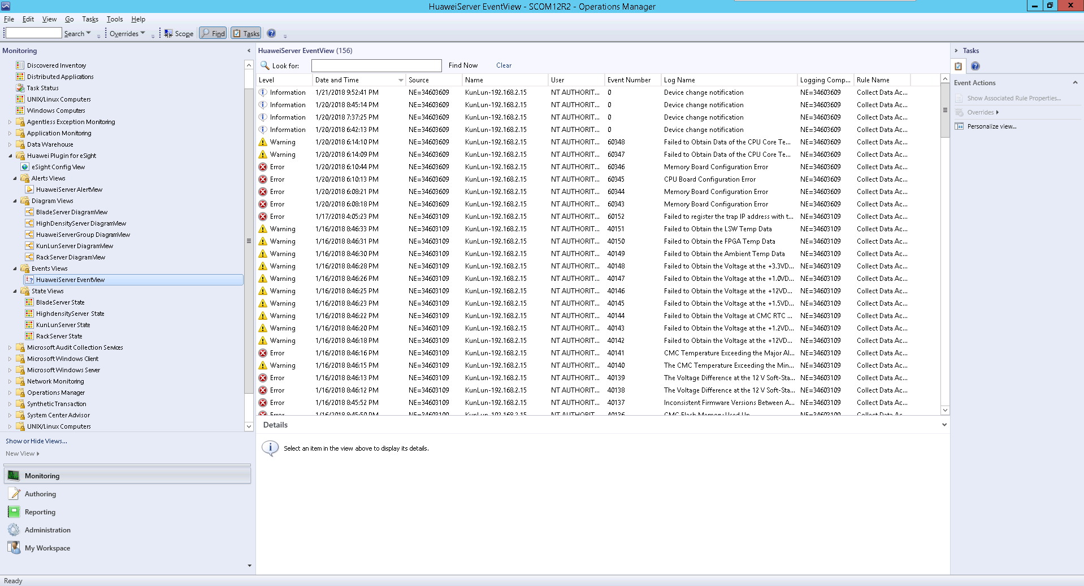

Table 1-1 describes the parameters.
                - Parameter description
Parameter | Description
Level | Event type. The options are as follows:  - Information: system running event  - Warning: minor alarm  - Error: major or critical alarm
Date and Time | Date and time when an event is generated
Source | Sensor that generates an event
Name | Device where an event is generated
User | Current user
Event Number | Event number. The value ranges from 0 to 65535.
Log Name | Event name
Logging Computer | Current login device
Rule Name | Rule name
----End

Viewing an Alarm List
            - Choose Start > > Operations Console.
The SCOM main window is displayed, as shown in Figure 1-1.
              - SCOM main window

            - Choose Monitoring > Huawei Plugin for eSight > Alerts Views > HuaweiServer AlertView.
In the HuaweiServer AlertView window that is displayed, click an alarm to view its details, as shown in Figure 1-1.
              - HuaweiServer AlertView
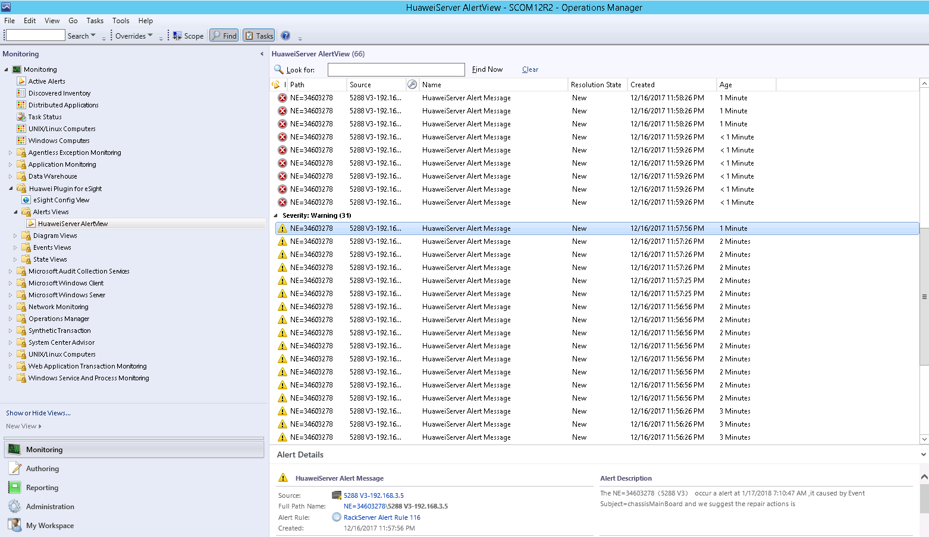

Table 1-1 describes the parameters.
                - Parameter description
Parameter | Description
lcon | Alarm type. The options are as follows:  - Warning: minor alarm  - Error: major or critical alarm
Path | Sensor that generates an alarm
Source | Device where an alarm is generated
Name | Alarm name
Resolution State | Handling status
Created | Time when an alarm is generated
Age | Duration of an alarm
----End

Viewing Server Topologies

Viewing a Huawei Server Topology
Huawei server topologies include the topologies of blade servers, rack servers, high-density servers, and KunLun servers. The following sections describe different types of server topologies.
            - Choose Start > > Operations Console.
The SCOM main window is displayed, as shown in Figure 1-1.
              - SCOM main window

            - Choose Monitoring > Huawei Plugin for eSight > Diagram Views > HuaweiServerGroup DiagramView.
The HuaweiServerGroup DiagramView window is displayed, as shown in Figure 1-1.
              - HuaweiServerGroup DiagramView
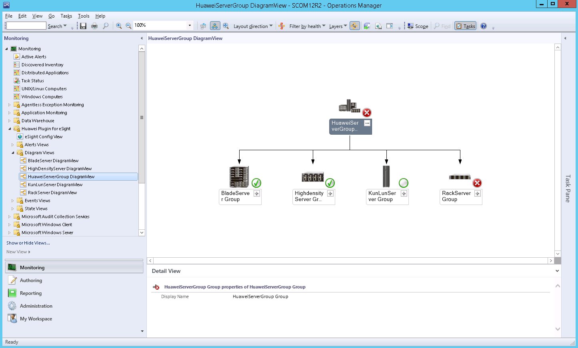

If the current version is not the latest version, perform the following operations to view the latest topology:
            - Open the CLI of the SCOM server.
            - Access the SCOM installation path (C:\Program Files\System Center Operations Manager 2012\Console) on the CLI.
            - Run the following command to refresh the SCOM window:
Microsoft.EnterpriseManagement.Monitoring.Console.exe" /clearcache
In the HuaweiServerGroup DiagramView area, click on any server icon to expand the topology of the server type, as shown in Figure 1-2.
              - Topology
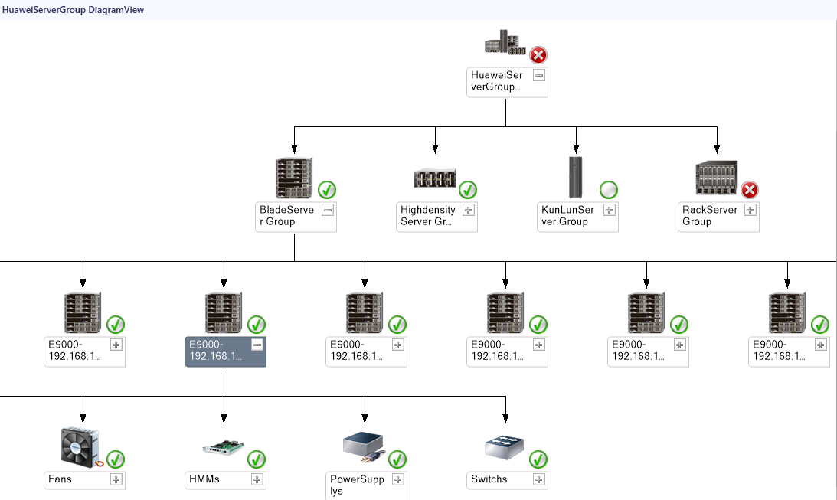

----End

Viewing a Blade Server Topology
            - Choose Start > > Operations Console.
The SCOM main window is displayed, as shown in Figure 1-1.
              - SCOM main window

            - Choose Monitoring > Huawei Plugin for eSight > Diagram Views > BladeServer DiagramView.
The BladeServer DiagramView window is displayed, as shown in Figure 1-1.
              - BladeServer DiagramView
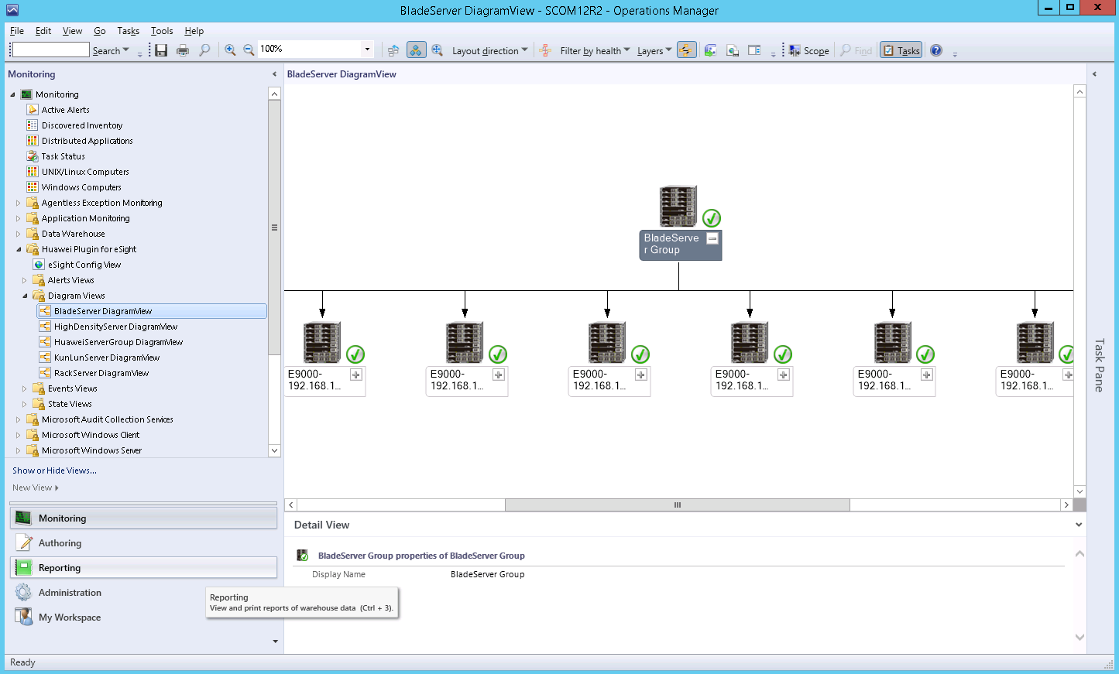

If the current version is not the latest version, perform the following operations to view the latest topology:
            - Open the CLI of the SCOM server.
            - Access the SCOM installation path (C:\Program Files\System Center Operations Manager 2012\Console) on the CLI.
            - Run the following command to refresh the SCOM window:
Microsoft.EnterpriseManagement.Monitoring.Console.exe" /clearcache
In the BladeServer DiagramView area, click on any server icon to expand the topology of the server type, as shown in Figure 1-2.
              - Topology
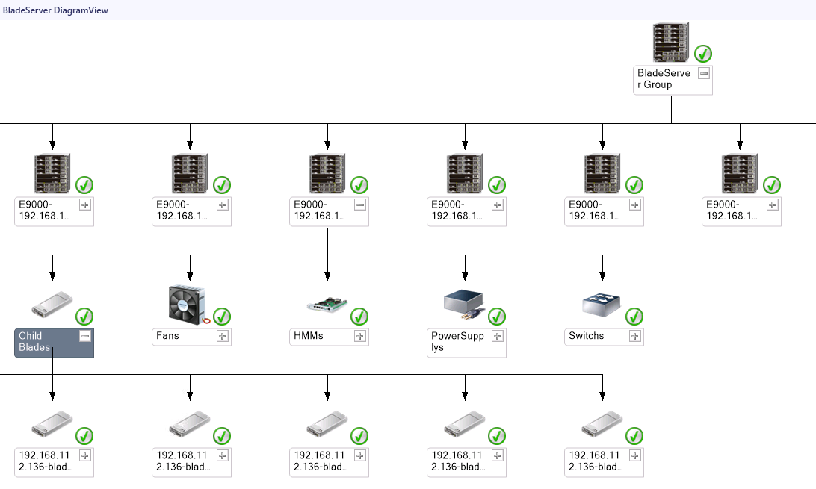

----End

Viewing a Rack Server Topology
            - Choose Start > > Operations Console.
The SCOM main window is displayed, as shown in Figure 1-1.
              - SCOM main window

            - Choose Monitoring > Huawei Plugin for eSight > Diagram Views > RackServer DiagramView.
The RackServer DiagramView window is displayed, as shown in Figure 1-1.
              - RackServer DiagramView
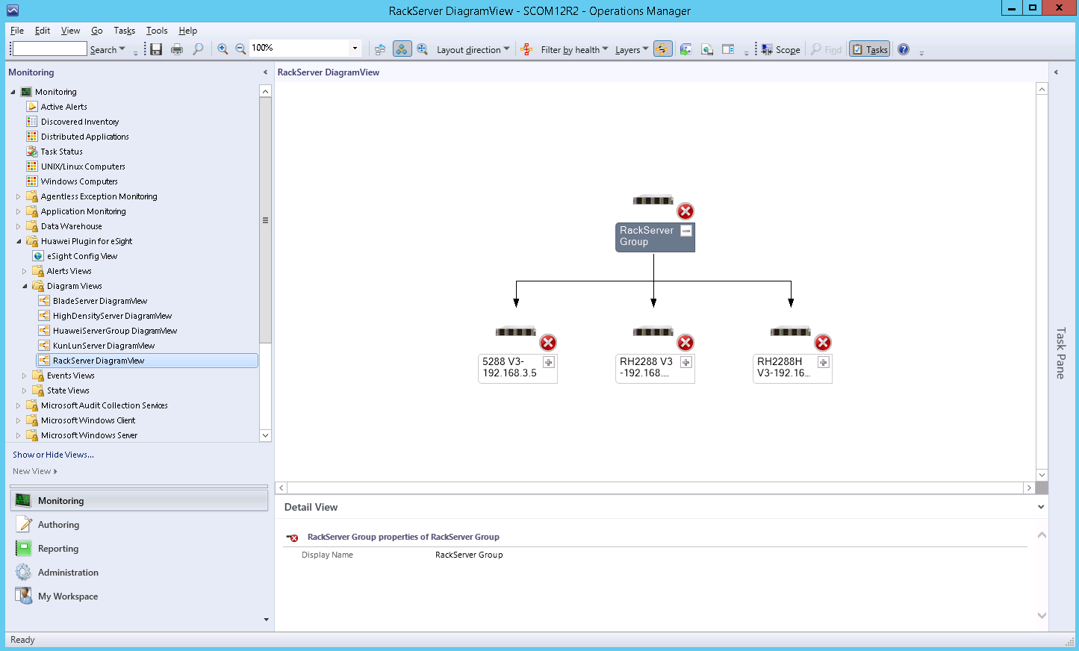

If the current version is not the latest version, perform the following operations to view the latest topology:
            - Open the CLI of the SCOM server.
            - Access the SCOM installation path (C:\Program Files\System Center Operations Manager 2012\Console) on the CLI.
            - Run the following command to refresh the SCOM window:
Microsoft.EnterpriseManagement.Monitoring.Console.exe" /clearcache
In the RackServer DiagramView area, click on any server icon to expand the topology of the server type, as shown in Figure 1-2.
              - Topology
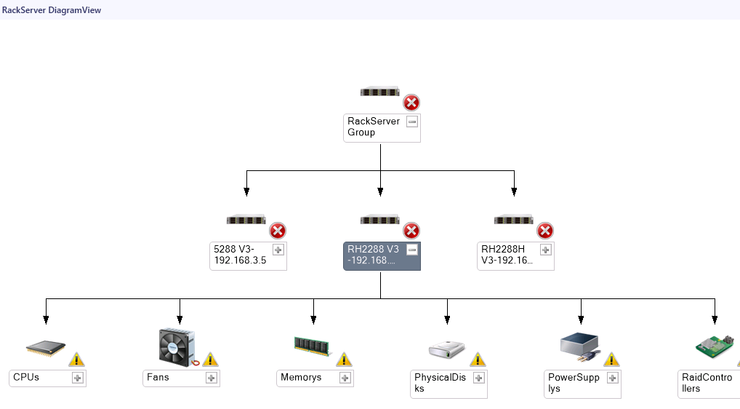

----End

Viewing a High-Density Server Topology
            - Choose Start > > Operations Console.
The SCOM main window is displayed, as shown in Figure 1-1.
              - SCOM main window

            - Choose Monitoring > Huawei Plugin for eSight > Diagram Views > HighDensityServer DiagramView.
The HighDensityServer DiagramView window is displayed, as shown in Figure 1-1.
              - HighDensityServer DiagramView
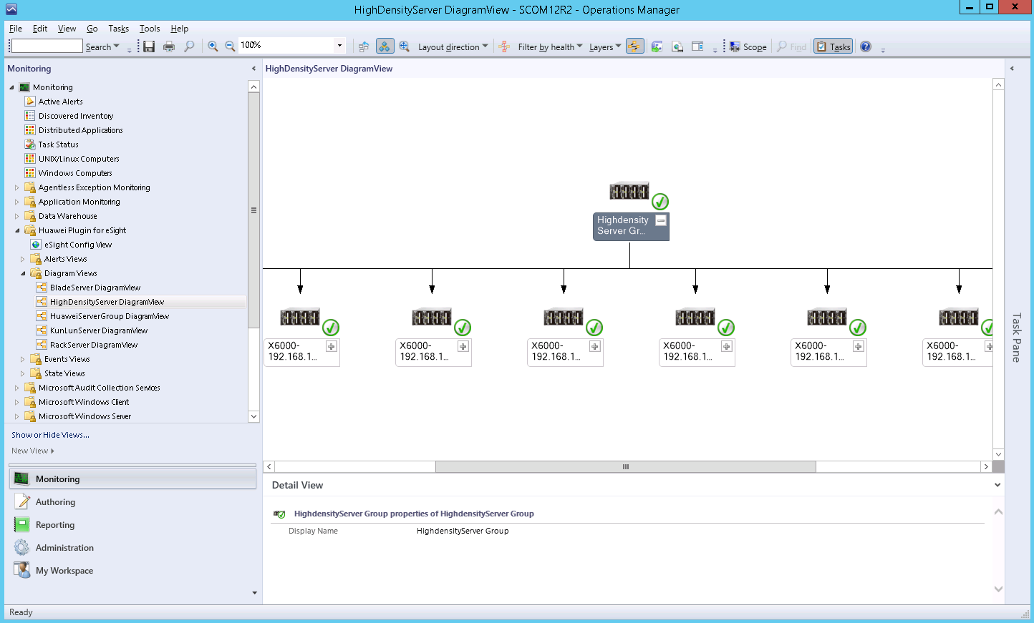

If the current version is not the latest version, perform the following operations to view the latest topology:
            - Open the CLI of the SCOM server.
            - Access the SCOM installation path (C:\Program Files\System Center Operations Manager 2012\Console) on the CLI.
            - Run the following command to refresh the SCOM window:
Microsoft.EnterpriseManagement.Monitoring.Console.exe" /clearcache
In the HighDensityServer DiagramView area, click on any server icon to expand the topology of the server type, as shown in Figure 1-2.
              - Topology
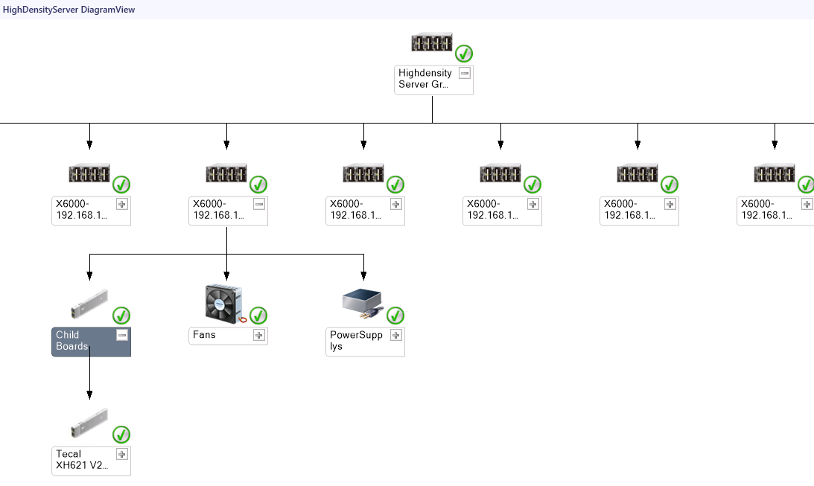

----End

Viewing a KunLun Server Topology
            - Choose Start > > Operations Console.
The SCOM main window is displayed, as shown in Figure 1-1
              - SCOM main window

            - Choose Monitoring > Huawei Plugin for eSight > Diagram Views > KunlunServer DiagramView.
The KunlunServer DiagramView window is displayed, as shown in Figure 1-1.
              - KunlunServer DiagramView
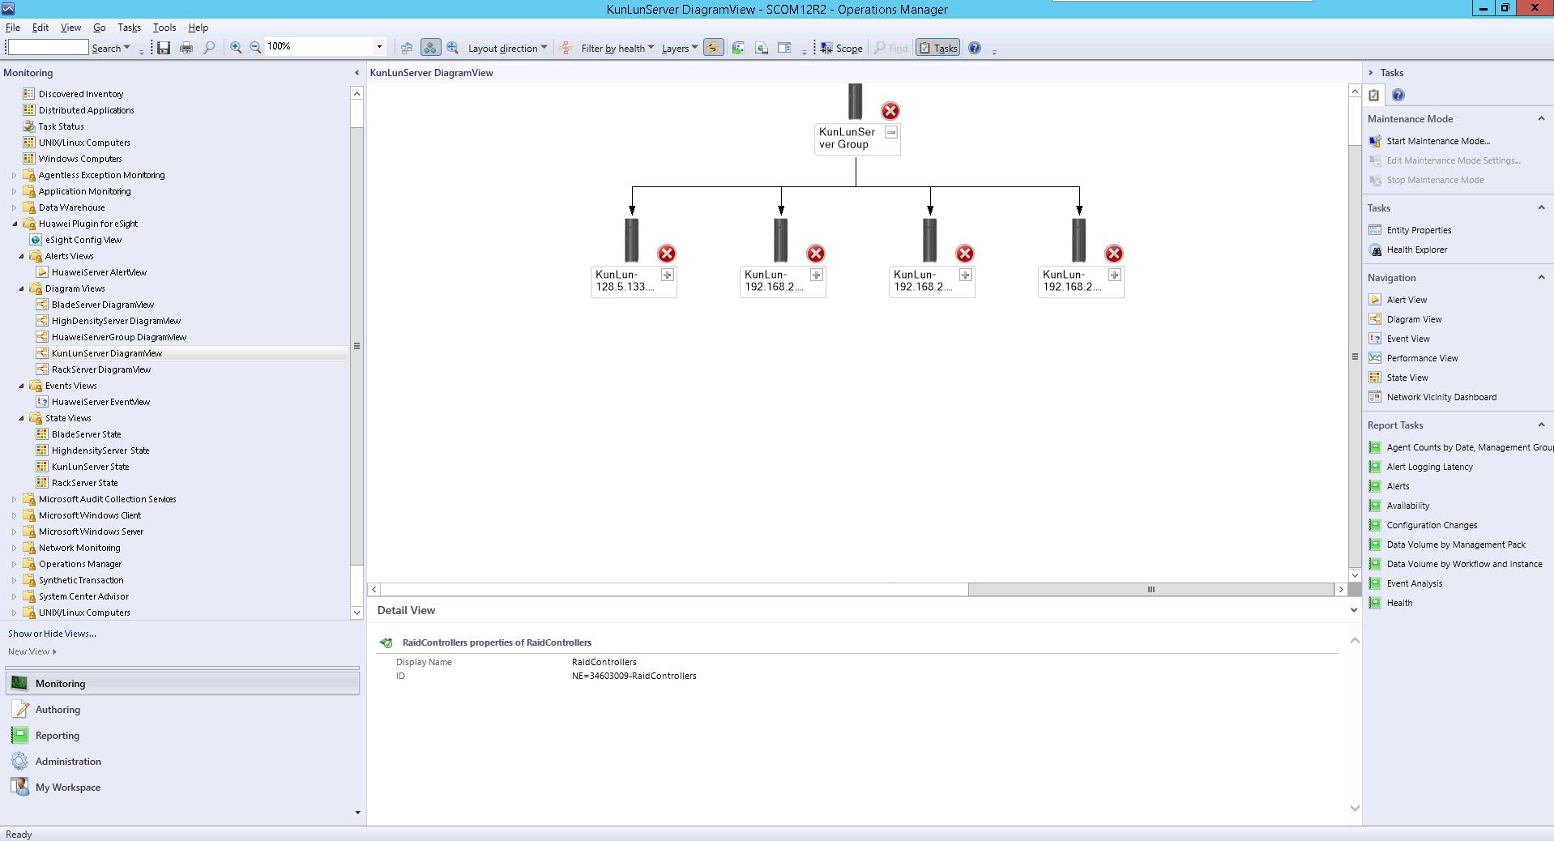

If the current version is not the latest version, perform the following operations to view the latest topology:
            - Open the CLI of the SCOM server.
            - Access the SCOM installation path (C:\Program Files\System Center Operations Manager 2012\Console) on the CLI.
            - Run the following command to refresh the SCOM window:
Microsoft.EnterpriseManagement.Monitoring.Console.exe" /clearcache
In the KunlunServer DiagramView area, click on any server icon to expand the topology of the server type, as shown in Figure 1-2.
              - Topology
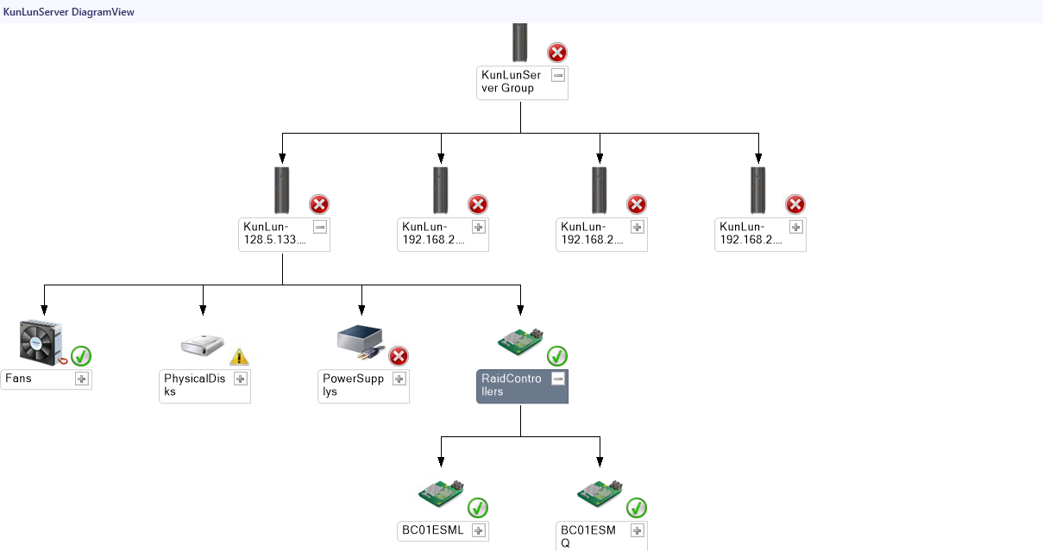

----End
- Glossary
E
eSight | eSight is a platform related to Huawei server management.

N
NetFramework | Microsoft .NET Framework is a new hosting code programming model used for Windows. It combines powerful functions with new technologies to construct applications with excellent user experience, implement seamless communications across technical boundaries, and support various service processes.

S
SCOM | System Center Operation Manager (SCOM) refers to the Microsoft system center operation manager. SCOM monitors servers, application systems, and clients in the network. It provides a GUI for administrators to monitor faults and alarms of target computers.

